IBM CLOUD SERVICES :

SUCCESSFULLY CREATED IBM CLOUD SERVICES

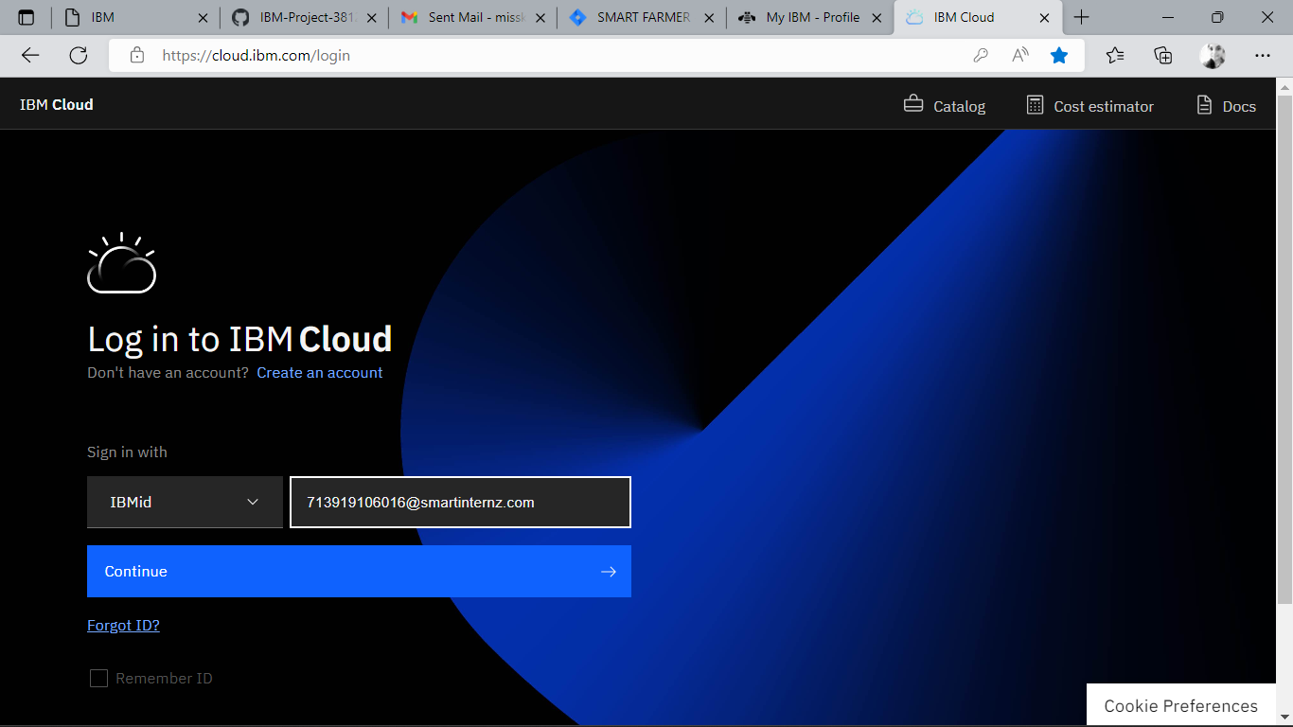

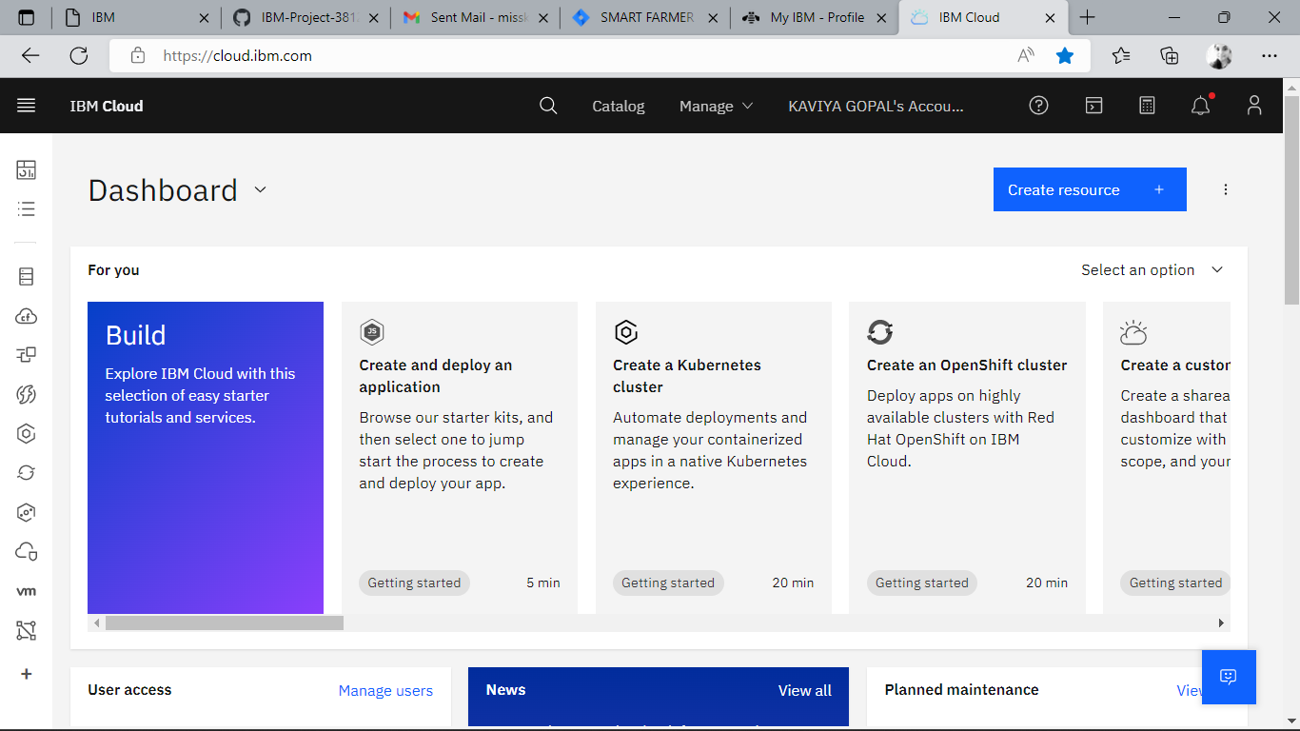

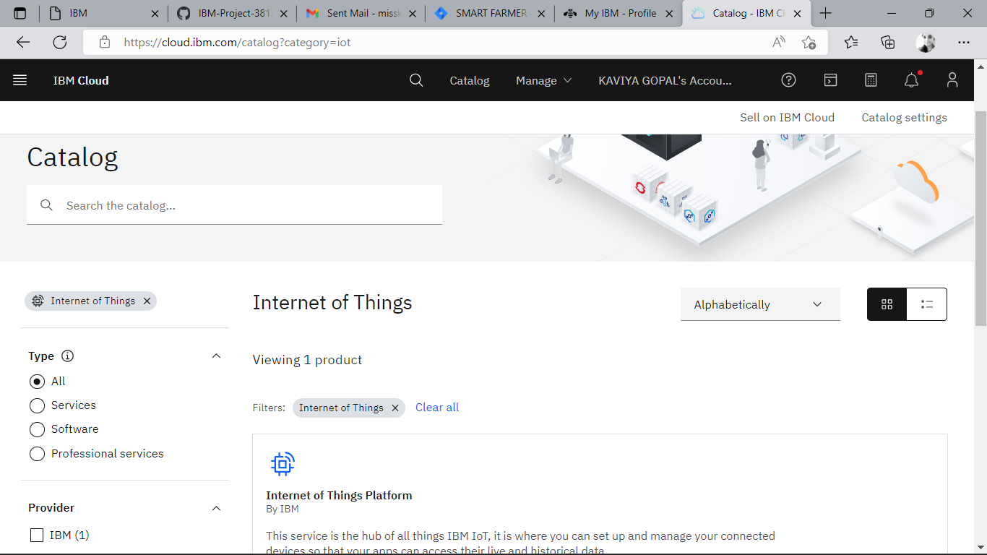

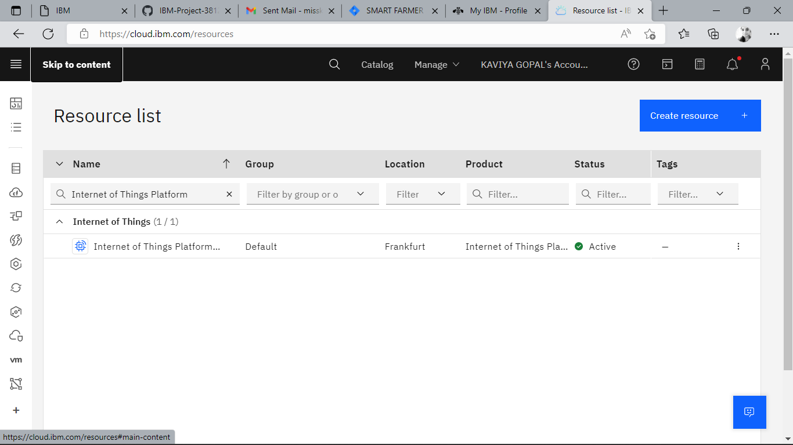

MIT APP INVENTOR

SUCCESSFULLY CREATED ACCOUNT IN MIT APP INVENTOR

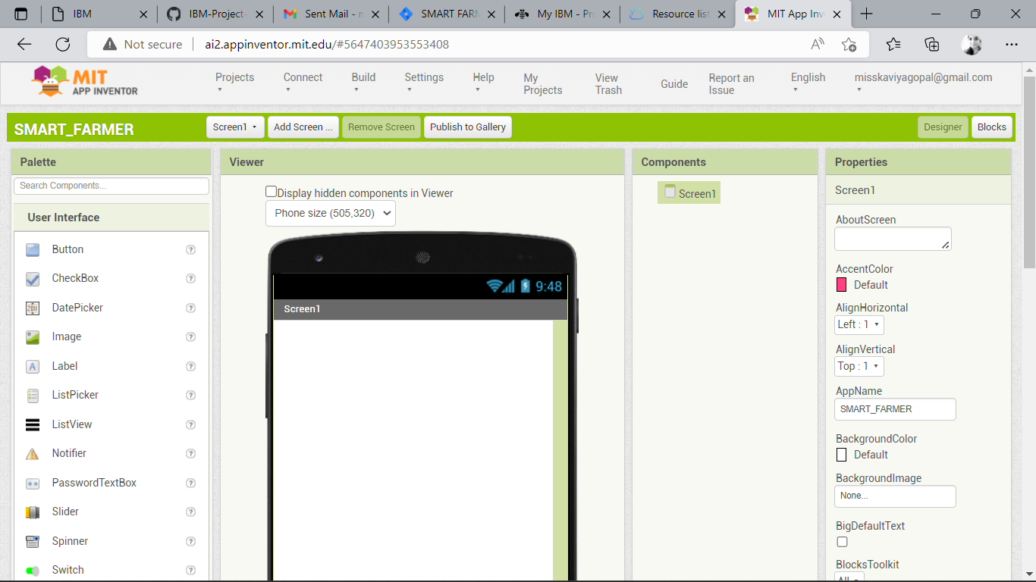

SOFTWARE:

THE REQUIRED SOFTWARE PYTHON 3.9.8 IS SUCCESSFULLY INSTALLED

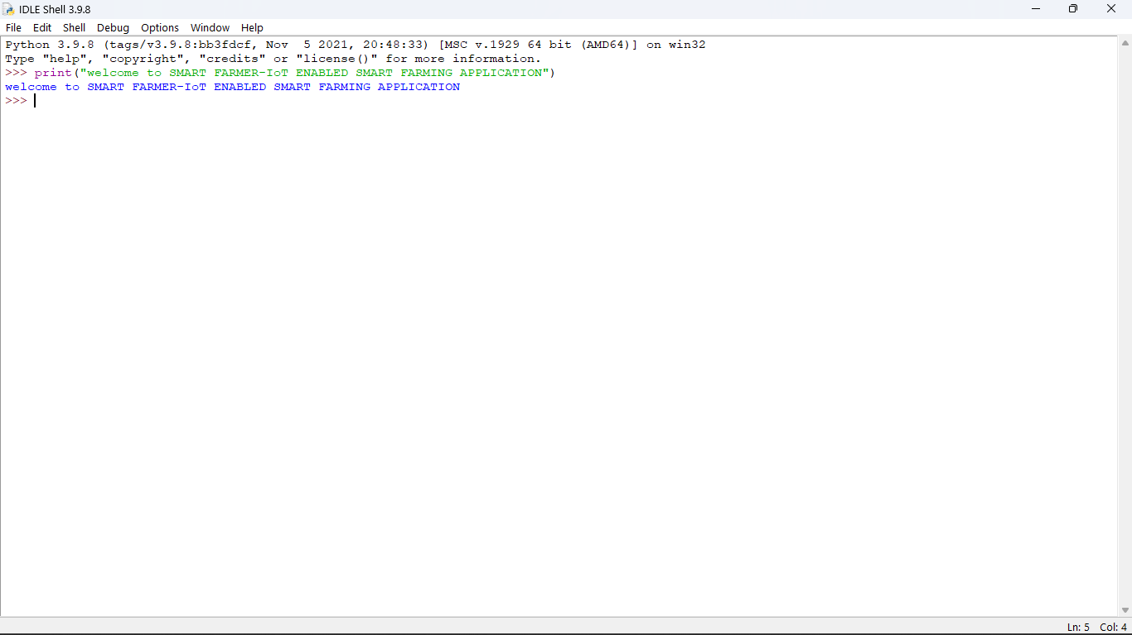

ACCOUNT IN FAST2SMS DASHBOARD:

ACCOUNT IN FAST2SMS DASHBOARD IS SUCCESSFULLY CREATED

